APPENDIX H–WRDB 4.1 ENHANCEMENTS

Introduction
WRDB 4.1 enhancements were authorized by Region IV EPA in the Fall of 2000 and the contract was administered through Mohammed Lahlou of Tetra Tech, Inc. This contract contained the following tasks:
- Make database structure and programming enhancements to improve the access speed of large amounts of data so that data subsets can be extracted across a PC network in a reasonable time. The prototype database structure enhancements demonstrated for Georgia STORET data will be applied to the remaining states in the Region.
- Perform testing on the WRDB system to determine what enhancements will be required to allow normal and new "optimized" structure (faster search and query capability) tables to coexist and provide tools for converting to and from the standard and optimized formats.
- Enhance query forms to allow "drill-down" queries, that is, queries on previous query results to allow the user to successively refine his query results much faster than before. Also enhance the WRDB Stations Support table to include the station's segment and marker ID.
- Prepare an appendix to the WRDB user's guide providing guidance to users for efficiently querying very large STORET tables. Other documentation updates will not be performed as part of this contract.
These and other enhancements that comprise WRDB 4.1 will be described in the appendix.

Table Structure Enhancements

Data Tables
The structure of data tables (that is, Working, Master, and Alternate tables) is now much more flexible. The basic structure described in the User’s Guide is retained (Station ID, Date-Time, PCode, CCode, LEW, Depth, RCode, Result, Validated, and Track ID), however the table now may optionally contain a new first field called INDEX, which should be a unique number that can be used as a primary key, and may contain an unspecified number of fields following the Track ID; these are indexed fields copied from one or more Support tables. Primary keys, field indices, and added indexed fields are all used to “optimize” Master tables to greatly speed queries (as discussed in a moment).

Support Tables
A new field “Reach_ID” has been added to the Stations Support table. This is a 25-character field intended to hold a stream reach identifier such as is used in standard RF3 ArcView themes.

Advanced Menu Add-In
The Add-In Manager has been modified to allow the user to turn on and off so-called advanced menu items. Having these menu items off reduces the clutter of having so many program features displayed to novice users.
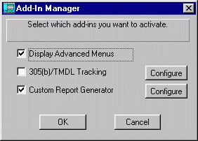
When this add-in is checked, the following menu items are displayed:
File | Open SQL Server Table (if a SQL Server alias is defined)
File | File Management | Working | Display Table Locks
File | File Management | Master | Display Table Locks
File | File Management | Master | Modify Table Structures
File | File Management | Display Network Users…
File | File Management | Set Private Directory…
File | File Management | Table Repair Utility…
File | File Management | SQL Server/MSDE Manager…

Modify Data Table Structure Utilities
An “optimized” Master table is one with a Primary key field (if it is a Paradox table), one or more indexes, and optionally one or more added indexed fields. Master tables should be optimized only after they have “stabilized”, that is, when records are no longer being added to them (such as STORET archives).
Optimized tables can be queried much faster than unoptimized tables. For example, using a 900 Mhz Pentium III computer on a 100 Mbps local area network, a simple query which extracts 5000 records by Station ID from an 11 million record Master table located on the file server takes 214 seconds. That exact same query performed after the Station ID index has been created takes only 0.25 seconds (900 times faster).
Another form of optimization involves the copying of selected Support table fields to the Master data table. For example, the hydrologic unit code (HUC) is a field in the Stations table. To extract data by this field, the Master and Stations tables must be internally “joined”, which makes the queries quite time-consuming. Copying the HUC field from the Stations table and adding it to the Master table gives a less efficient database design and causes the Master table to get about 10 percent larger. However, using the same benchmark situation described earlier but which extracted over 5,000 records from a 3 million record table located on a fast local hard disk, queries on the HUC field in the Master table can be run 400 times faster than queries on the HUC field in the Stations table (query times drop from 80 seconds to 0.2 seconds).
WRDB 4.1 gives the user all the flexibility he needs to optimize and “unoptimize” files as he sees fit. Six menu items were added to the File | File Management | Master | Modify Table Structure menu, as described in the following sections.

Display Structure
This shows the user all the underlying details about a selected Master table’s internal structure. The average user would only use the information to determine which fields are indexed, and whether any additional fields have been added:
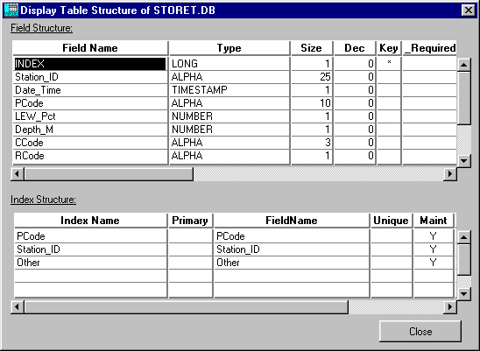
In the above example, a keyed field called INDEX has been added as well as an additional field called Other (if you scroll down). Also, secondary indices on the Station_ID, PCode, and Other field has been added. This would make queries on this field very fast.

Display Table
This option was added because indexed fields added by the user are not normally visible in the browser:
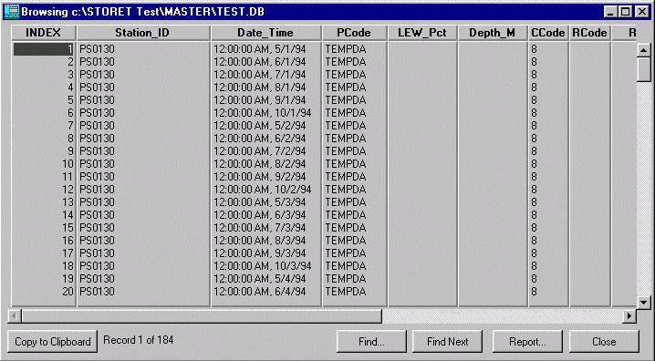

Primary Key
This option is used to add or remove a Paradox primary key from the Master table. A primary key is necessary to adding secondary indices (for Paradox tables only; SQL Server tables do not require a primary key). The primary key must be unique and is just an integer number equal to the record number. The addition of this field and the primary index causes the table to be significantly larger. For example, adding a primary key and one additional indexed field caused a sample Master table to go from 165 Mb to 505 Mb (three times larger). This is why standard WRDB tables are left unindexed. However, for relatively stable tables this disk space requirement is reasonable and as a result queries can be very fast on indexed fields, even over a slow LAN.
Adding and removing the primary key can take a long time; up to one hour for multi-million record tables on a fast local hard disk. Once added, it is self-maintaining and will provide very fast queries. Although it is possible to transfer data from a Working to Master table once the Master table has been optimized, the transfer operation will be slower.

Index
After a primary key is added, it is possible to select an existing field and create a secondary index on it. Good candidates for secondary indices are Station_ID and PCode. If a primary key does not already exist (and it is a Paradox table), the user is warned and the operation aborted. The following dialog is displayed:
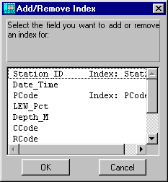
This shows all fields in the current table (except the one that is the primary key) and whether it is already indexed. The user can select a field that is already indexed to remove it, or select an unindexed field to add it.

Indexed Field
The current database design is normalized in such a way that there is the minimum amount of wasted disk space by the use of linked relational tables. The disadvantage of this is that when some queries require information from a linked table, query times can be excessive. The best example is querying data by HUC. The HUC field is unique to each station, and according to good database design principles, located in the Stations table. However, when data are retrieved by HUC, the database engine must internally link these tables and it can take a long time to perform the query. The “Indexed Field” menu item allows you to select any field (except the key field) in the Stations, PCode, or CCode table and add the contents to the current Master table:
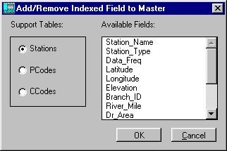
This causes WRDB to create a new field in the Master table with that name and populate it with data from the selected Support table. Finally, a secondary index is added on that new field. This allows queries on these added fields to be very fast (although, again, more disk space is required).
Software enhancements which allow optimized Master tables can be used transparently with normal Master tables. The only limitation is that with Working table records are transferred to an optimized Master, the contents of any additional fields will not be automatically updated. The user is warned of this and told to remove then re-add affected fields after all transfers are complete. Because of the overhead of maintaining secondary indices during the transfer of Working data, it may be faster to actually remove all extra fields and indices before doing a large set of transfer operations. These considerations are minor in light of the fact that optimized files will only very rarely be updated.

Append Alternate Table
This menu item allows you to append records from an Alternate table to a Project’s Master table. This utility was added to speed the process of building large Master tables. It avoids the need to validate and transfer data from Working tables, which can be quite time consuming.

SQL Server/MSDE Manager
The Paradox database system is quite compact and fast, especially with the enhancements to the Master tables made for WRDB 4.1. As documented in Appendix F of the User’s Guide, WRDB also is able to store tables on several different kinds of SQL servers (namely Oracle, Microsoft SQL Server, and MySQL). This client/server approach has a number of advantages over Paradox’s file system approach. However, it can be somewhat expensive to purchase a SQL Server program and difficult to install and manage it.
Microsoft has made available a no-cost version of SQL Server called MSDE (Microsoft Database Engine). It works just like SQL Server, but can only efficiently handle five to ten simultaneous users. Furthermore, although MSDE is available free of charge, Microsoft includes no database administration software to set up databases and maintain security. To make up for this shortfall and allow WRDB users to fully exploit MSDE, the SQL Server/MSDE Manager utility was created. When invoked from the File Management menu, the following is displayed:
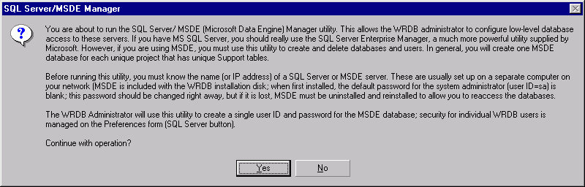
When you click “Yes”, the manager form is shown. At the top of the form, you must enter the Server Name and administrator password to log in:
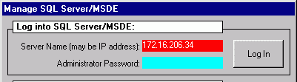
After you successfully log into the MSDE server, the rest of the form is accessible:
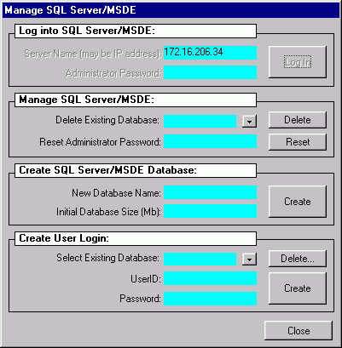
Using the SQL Server/MSDE Manager, you can delete an existing database (the drop-down contains a list of previously created databases) and reset the administrator password (when first installed, the administrator (user ID = sa) password is blank; it is wise to reset this).
You can create a new database with a specified size. Finally, you can delete and create users associated with a given database. Recall that all WRDB users share the same SQL Server username and password, and the SQL Server button on the Preferences dialog controls individual WRDB user access.
Most commonly, a separate MSDE database would be set up for each WRDB Project (that has unique Shared Support files). For example, suppose EPA Region IV headquarters retains STORET data for North Carolina and South Carolina. Because the Support files for these datasets are unique, EPA would have to set up two MSDE databases on an MSDE server, each of which contains the Shared Support files and Master tables for each state. The EPA WRDB user would then have to set up two ODBC dataset names and BDE Aliases; they both point to the same SQL Server, but different database names (and possibly WRDB usernames and passwords).
The WRDB Administrator is responsible for making backups of the MSDE databases using separate operating system techniques (WRDB file management utilities cannot be used).
The MSDE Server can be installed from the WRDB installation CD by selecting the subdirectory “MSDE Server” and running the program “Setup.exe”.

Display Network Users
This utility was added to display all Paradox network users active at a given time. This displays only those users that have the same network directory (BDE NETDIR setting) as you:
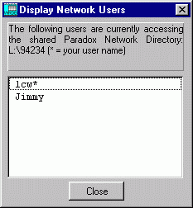

Multi-Parameter Entry Form
The multi-parameter entry form has been enhanced to facilitate selection of Station IDs, PCodes, and CCodes, and to allow you to directly import data into it. The maximum number of columns has been increased from 20 to 40.
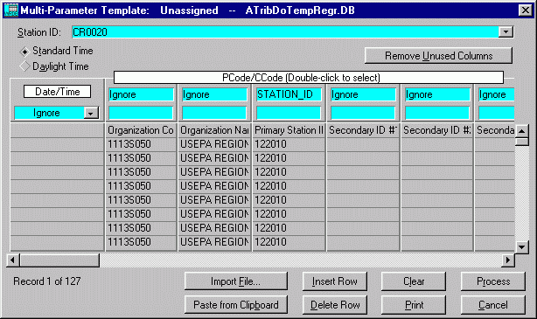
The Station ID drop-down list now includes station names. To select PCodes and CCodes, you just double-click on the field to display a list containing codes and descriptions:
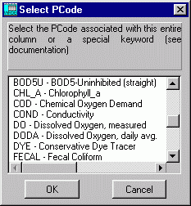
Besides PCodes, you can also now select from a list of special keywords, just like in DBCONV.
Text files that are comma delimited or tab delimited can be imported (the program automatically detects whether tabs are used). Fields may be quote-delimited as well. In addition, you can import data from a variety of spreadsheet and database programs. The multi-parameter form can only import data in the “tabular” format (see Appendix C of the User’s Guide). Click Import File… to browse to a data file and import it.
Click Paste from Clipboard to import the contents of the Windows clipboard (which must be tab- or comma-delimited). This option can be handy for importing data from a portion of a spreadsheet or an Internet page.
The above example shows data imported from the legacy STORET system on the Internet (www.epa.gov/storet). For example:
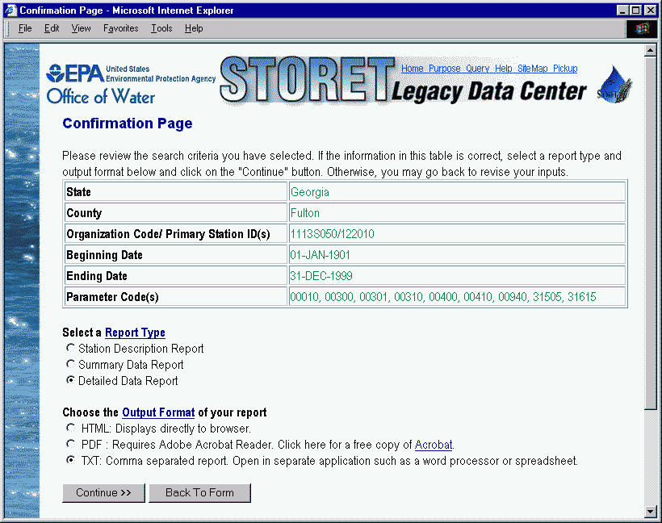
As of this writing, queries resulting in 700 or fewer results are presented in a web page:
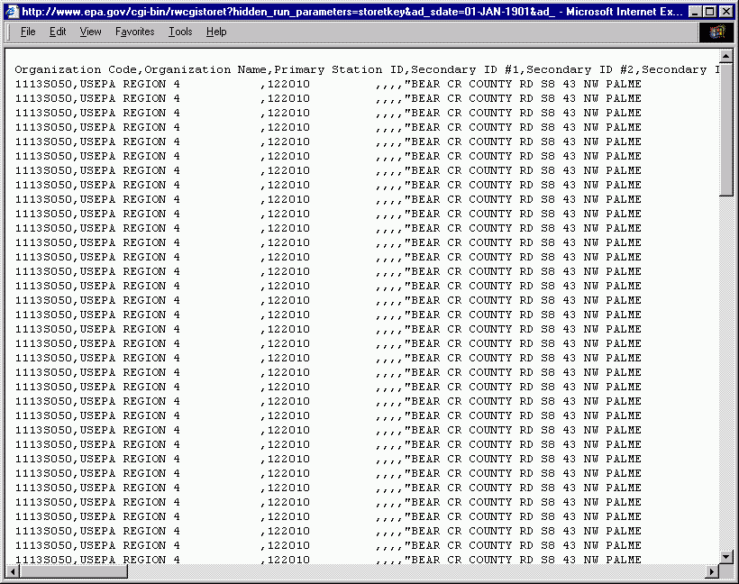
It is most convenient to import these data by selecting Edit | Select All then Edit | Copy (or press Ctrl+A, Ctrl+C), then switch to WRDB and click Paste From Clipboard. When more than 700 values are queried, STORET runs the query at night and instructs you to pick up the text file the next morning. This text file contents can be pasted or you can download and import it using Import File….
Many of the columns downloaded from the online STORET should be left as IGNORE. You need to use the special column headings STATION_ID_STORET, AGENCY_STORET, PCODE_STORET, and RCODE_STORET to properly interpret the data. The first line of column headings can be used to assign the column heading codes, then that line can be deleted. It is very convenient to save the column headings as a named multi-parameter format that can be reused.
As of this writing, the modernized STORET system on the Internet contains no data.

Import DSS Data
DSS (Data Storage System) was created by the U.S. Army Corps of Engineers to efficiently store very large quantities of historic data and simulation results. These data can be imported into a Working table by selecting Edit | Import DSS Data. After selecting the DSS file, the following dialog appears:
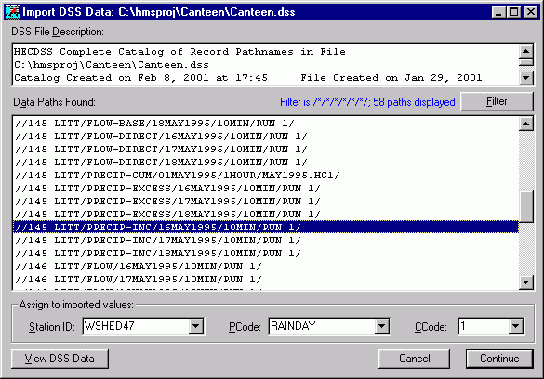
The top pane contains the DSS file description. Data paths are listed below that. You can display a subset of the data paths by clicking on the Filter button and entering the path specifications. For example, /*/*/FLOW*/*/*/*/ indicates that only those paths whose “C-Part” begins with “FLOW” should be displayed.
Select one or more paths using the mouse and the Shift or Cntl keys. Only regular time series data (RTS) can be extracted. You can preview the data in the paths by clicking the View DSS Data button.
Select the Station ID, PCode, and CCode to assign to all data values, then Continue to import the data using DBCONV.

Drill-down Queries
All query forms now have the option of performing a drill-down query in which subsequent queries extract data from prior query results. This can allow you to very quickly narrow your search to just the data you need. For example, the Advanced Query form now looks like this:
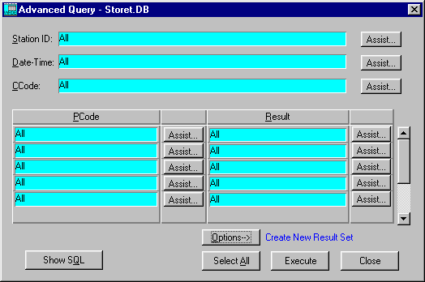
The Options button that three query options:
- Select from browser and create new result set
- Select from browser and add to previous result set
- Select from previous result set and replace (drill-down)
The first two options correspond to WRDB 4.0 options, and the third allows the user to perform successive queries, “drilling down” to the desired results. This has proven to be quite efficient in extracting data from large datasets.

Advanced Query
The Advanced Query Assistance form has been enhanced. Now, the entire support table is displayed on the form as follows:
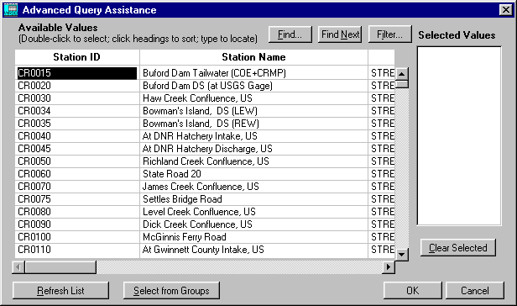
Prior to WRDB 4.1, only the ID and name were displayed. With all this information in the form, you can narrow your search for the data quite easily (perhaps without resorting to opening the Stations form or doing GIS queries). This form has the following features:
- you can double-click on any row to cause the Station ID to be copied to the Selected Values box to the right (as before)
- you can sort on any column by just clicking the column heading
- once sorted, you can start typing the field that is highlighted to have the table jump to that record; for example, you can sort by Station Name, then type “S” to have it jump to station names starting with that letter; this implements the oft-requested word-wheel concept used by EarthInfo
- click the Find button to bring up the record search dialog:
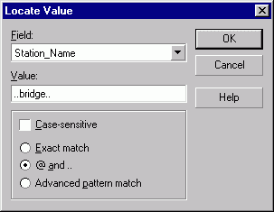
In this example, the user is using QBE criteria to search for any station name that contains the word “bridge”. The Find Next button finds the next occurrence.
- you can click the Filter button to display a subset of the records in the Support table:
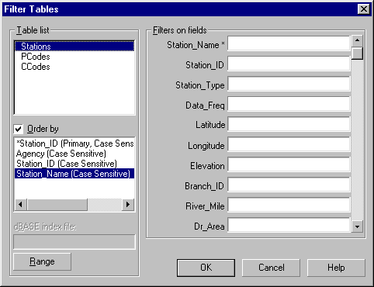
Using QBE criteria, you can specify conditions for which the data will be displayed; for example, if you know that the station name begins with “Sweet” and it is a USGS station, just enter “Sweet..” for the Station_Name and USGS for the Agency field. This may remove the need to search for station information on the GIS prior to extracting data.
- the Refresh List button displays only those stations found in the current Working or Master table.
- The Select from Groups button has also been enhanced so that when selecting from groups, a list of the station IDs in a selected group is added (rather than causing the query to link to the station group Support table which causes queries to run much slower).

WRDB Graph Enhancements

General
The graph form has been made resizable.

Depth and Width Profiles
Two additional graph options have been added: Output | Graphs | Depth Profile and Width Profile. The next graphic shows a depth profile:
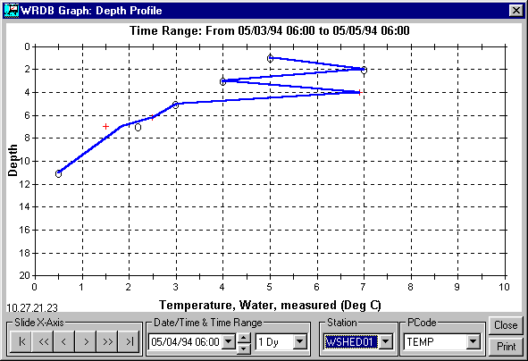
This graph format is similar to the longitudinal profile, recognizing that the dates and times of various observations at depth might not be identical. It is therefore necessary to provide a date/time range so you can see the time dimension in the form of the symbology (just like the longitudinal profile). The display of lines/symbols for these types of graphs. Also, clicking on the date/time box brings up a calendar, making it easier to select a date. You can also animate these graphs so you can see time-lapse graphs.
It can be difficult to know what date to specify when displaying data. A new option has been added to display all data in the graph; just right click on the graph and select Display Data to see a dialog like this:
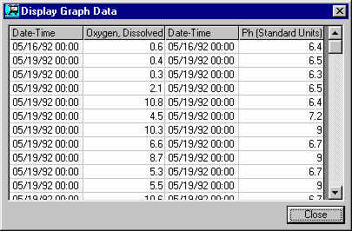

Custom Report Enhancements
The custom report add-in was added for WRDB 4.0. It utilizes the Crystal Reports interactive report designer to create reports using WRDB data. A limitation that existed previously involved the fact that you would usually like to report on data last queried using WRDB and this table is stored in the Private directory as Tempdata.db. Unfortunately, Paradox locks this directory while in use, and Crystal Reports was not able to open the Tempdata.db file while WRDB was executing.
To work around this problem, WRDB now creates a copy of Tempdata.db and places it in the Windows temporary directory (usually C:\Windows\Temp) as CRData.db. This directory and file are not locked by Paradox, so you can design the report as desired. When activating the add-in, this is explained in this informational dialog:
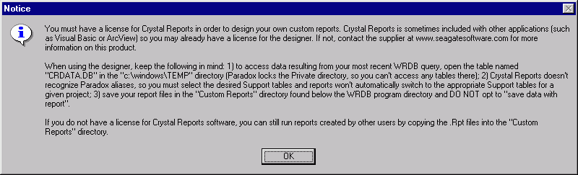
Each time a custom report is run, the most recently queried data is copied to CRData.db so your custom reports are always working with the most recent data.

STORET Projects Created by State in EPA Region IV
Data were downloaded from EarthInfo CDs to form STORET projects for each state within EPA Region IV. In addition, all USGS available within the Region were downloaded and a separate project was created. Because STORET station IDs are not globally unique, it was necessary to append the agency code to form the WRDB station IDs (in the form Station_ID+Agency_ID). STORET RCodes were converted to WRDB standards. In some cases, the dates for the STORET observations were invalid; all such data were assigned a date of 1/1/1900.
In all cases, a primary key was created and the master table was also indexed on Station ID and PCode. Furthermore, the HUC field was added from the Stations Support table and indexed.
Some statistics for these projects are shown below:

Project | Disk Space (Mb) | Number of Stations | Number of PCodes | Number of Observations | Period of Record
Alabama | 921 | 16,310 | 2,498 | 5,932,779 | 04/04/1906  02/27/1998
Florida  (2 Master Tables) | 3,120 | 57,479 | 15,810 | 10,833,892  6,816,039 | 10/11/1901  01/20/1998
Georgia | 1,260 | 8,529 | 2,500 | 5,714,741 | 10/18/1906  01/29/1998
Kentucky | 630 | 15,009 | 2,984 | 4,042,265 | 04/16/1904  12/31/1997
Mississippi | 432 | 8,751 | 2,976 | 2,773,343 | 05/18/1911 06/25/1997
North Carolina | 990 | 21,228 | 2,611 | 6,570,067 | 01/21/1908  03/18/1998
South Carolina | 928 | 16,237 | 2,626 | 5,978,188 | 05/01/1907  02/26/1998
Tennessee | 1,200 | 11,529 | 2,968 | 7,971,482 | 05/23/1904  01/29/1998
USGS Region IV | 1,020 | 12,244 | 4,676 | 5,767,843 | 12/08/1901  04/03/1997
Totals | 10,501 | 167,316 | N/A | 62,400,639 | N/A

How to Efficiently Query WRDB Tables
The WRDB system should give you reasonable query speeds for all but the largest tables. When dealing with tables that exceed a few hundred thousand records, you can follow these tips to allow your queries to operate at peak efficiency:
- Optimize Master tables by adding a primary key and secondary indices using the procedures described in this appendix. It is much faster to optimize a table on a local hard disk and then copy the results to the network drive than to optimize it across the network.
- Whenever possible, perform initial queries based upon an indexed field, then perform drill-down queries on these results based on other fields. For example, if you need to extract data in a given date range for a given station, you may get better performance by first querying for the Station ID. Then, perform a drill-down query on these results using the date range. If you intend to perform multiple date range queries for that station, you may wish to save the first query results to a temporary Alternate file on your local hard disk, and then make subsequent queries against it.
- Avoid using linking queries against large tables. For example, it can be very time-consuming to select all data from stations with names like “Bear Creek*”. Alternatively, you can use the Advanced Query Assistance form to find the stations IDs that meet that criteria, and then select the data by station ID. Or, first select data having the PCode of interest, and then do a drill-down query using the QBE or SQL form.
- In some cases Paradox may give a non-helpful error message when performing linked queries on very large tables. Try to reformulate your query to perform it in steps.
- When extracting data by station or pcode group, use the Advanced query form which queries a list of items rather than linking to the group table.
- If you find that you frequently perform queries against a certain field contained in a Support table, consider adding it to the Master table as an indexed field. This can significantly increase the size of the table, but queries will run much faster. As an example, the HUC field was added from the Stations table to speed queries on STORET master tables.
- It is faster to perform a SQL query on a single value using the syntax STATION_ID = ‘12345’ than STATION_ID IN (‘12345’). It is much faster to perform a single query using STATION_ID IN (‘12345’,’67890’) than to perform two separate queries.
- Avoid using the Refresh List button on the Advanced Query Assistance form or checking the Automatically Fill Criteria checkbox on the SQL Query form when querying very large tables.
- If a previously stable (unchanging) Master table suddenly needs some significant updates (like you are adding another year of STORET data), it will be faster to first “unoptimize” the table by removing all added indexed fields, secondary indices, and the primary key. Then perform whatever updates are required and re-optimize the table.
- You may get significant performance improvements if you migrate your data to a database client/server environment like SQL Server/MSDE or Oracle. This is particularly true where very large tables reside on a fast database server and when relatively few records are retrieved across a slow network. You should store all Master tables and shared Support tables on the SQL Server.
- Use the fastest hardware available (600 Mhz Pentium III or higher) with plenty of RAM (at least 128 Mb). Be sure you have plenty of free disk space on your local hard disk, as temporary tables can consume a lot of space.
- If you accidentally start a query or report on a very large table (like you “Select All” 11 million records from the table) it is not possible to interrupt the process without pressing Cntl-Alt-Delete, selecting the WRDB application, and clicking End Task or restarting your computer. Although this is to be avoided if possible, in practice it has not been found to corrupt tables or have other adverse affect. If WRDB is abnormally terminated, Paradox locking files may be left in the same directory as the tables and cause error messages. After all users on the network have exited WRDB, those locking files (Paradox.lck and PDoxUsrs.lck) can be deleted.

